Contract Management
Use Case Document


 | Prepared By / Last Updated By | Reviewed by | Approved By | Approved By
Name | Anish Sharma | Akshay Katoch | Akash Mahajan | Abhishek
Role | Team Member | Team Member | Team Member | Team Member
Signature
Date | 03/04/2019 | 05/04/2019

Table of Contents
1.0 Introduction 3
1.1 Purpose & Scope of the document 3
1.2 Intended Audience 3
1.3 Use case ‘Supplier Registration’ 3
1.3.1 Use case attributes 3
1.3.2 Use Case Model 4
1.3.3 Business Rules 4
1.3.4 UI Requirements 4
1.3.5 UI Field Validations 5
1.4 Use case ‘Supplier Credential Authentication’ 6
1.4.1 Use case attributes 6
1.4.2 Use Case Model 7
1.4.3 Business Rules 7
1.4.4 UI Requirements 7
1.5 Use case ‘Admin registeration’ 6
1.5.1 Use case attributes 6
1.5.2 Use Case Model 7
1.5.3 Business Rules 7
1.5.4 UI Requirements 7
1.6 Use case ‘Admin Credential Authentication’ 6
1.6.1 Use case attributes 6
1.6.2 Use Case Model 7
1.6.3 Business Rules 7
1.6.4 UI Requirements 7
1.7 Use case ‘Contract Addition’ 6
1.7.1 Use case attributes 6
1.7.2 Use Case Model 7
1.7.3 Business Rules 7
1.7.4 UI Requirements 7
1.8 Use case ‘Pending Contracts’ 6
1.8.1 Use case attributes 6
1.8.2 Use Case Model 7
1.8.3 Business Rules 7
1.8.4 UI Requirements 7
1.9 Use case ‘Pending Suppliers’ 6
1.9.1 Use case attributes 6
1.9.2 Use Case Model 7
1.9.3 Business Rules 7
1.9.4 UI Requirements 7
1.8 Use case ‘Update Profile’ 6
1.8.1 Use case attributes 6
1.8.2 Use Case Model 7
1.8.3 Business Rules 7
1.8.4 UI Requirements 7

2.0 Database Design 8
2.1 Tables Structure 8
3.0 Change Log 10

Introduction

Purpose & Scope of the document
The purpose of this Use case document is to systematically capture requirements for the project and the system to be developed in terms of use cases. Functional use cases are captured in this document. It also serves as the input for the project scoping.

The scope of this document is limited to addressing the use cases from a user, quality, and non-functional perspective.

Intended Audience
Each member of the project team

Use case ‘Supplier Registration’

Use case attributes
Use Case Description:

This use case deals with the capture of user details. The ‘supplier’ here shall be the operator of the system and will be keying in the supplier information into the system.

Scope:

- Supplier registration

Actors:

- Supplier – the operator

Trigger:

Click ‘Submit’ button in the ‘Supplier Registration’ page.

Pre-Condition:

User being able to access the homepage & get redirected to the ‘Supplier Registration’ page upon click on ‘Register as supplier ’ link.

Post Condition:

Supplier is in the registration page & submit details.

Flow of Events:

Supplier at login page → Click ‘Register as supplier’ link → Supplier is in the registration page → Supplier details are submitted and added onto the database

Primary Scenario:
A new supplier – is able to click ‘Register as supplier’ link and able to provide his details and get enrolled in the system.

Business Rules

Business rules should be defined using the following attributes: -

- When the supplier clicks on the registration link, it should re-direct to registration form.
    - Supplier needs to fill some of the basic attributes/fields as mentioned below in requirement: First Name, Last Name, Age, Gender, Contact Number, User Id, Password
- Clicking ‘Submit’ should validate the datatype constraints for each field
- Post-successful field level validation, save the information in the database
- Upon saving the information in the database, display the message ‘Your details are submitted successfully’.

UI Requirements

Here is a prototype on how the homepage should look like.

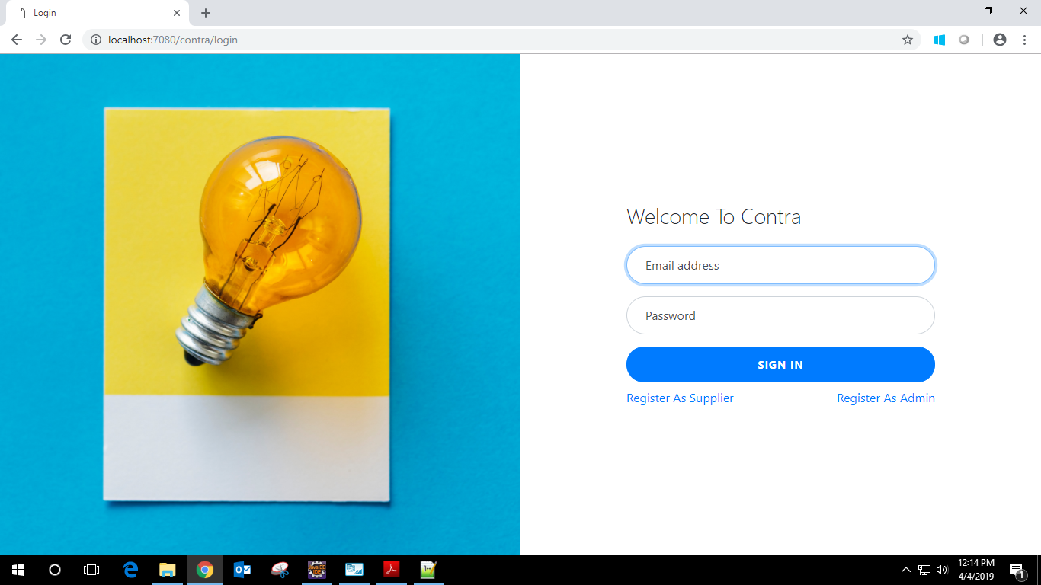

Here is a prototype on how the ‘Supplier Registration’ page should look like.

UI Field Validations
Please refer to the below requirements for field level validations:

- All fields are mandatory.
- Username should be less than 30 chars. Password should have minimum 8 chars, no space & can contain special characters (ex.!,@,#,%,*,& etc.)
- Password and Confirm Password fields should be the same
- The Email ID format must be checked. (For ex. test@testmail.com.)
- Phone Number must be of 10 digits’ length

Use case ‘Supplier Credential Authentication’

Use case attributes
Use Case Description:

This use case deals with the authentication of the user credentials. The ‘supplier’ here shall be the operator of the system and will be keying in the Contract information into the system.

Scope:

- User credentials authentication

Actors:

Supplier – the operator

Trigger:

Click ‘Sign In’ link, after keying in ‘Username’ & ‘Password’ field.

Pre-Condition:

Supplier being able to access the dashboard.

Post Condition:

Supplier is in the Contract Addition page.

Flow of Events:

Supplier at login page → Key in ’username’ & ‘Password’ field → Supplier credentials are validated → Supplier homepage is displayed

Primary Scenario:
A registered supplier – is able click ‘Sign In’ link, after keying in ‘username’ & ‘Password’ field and get his credentials authenticated with the existing database entry.

Alternative Scenario:
A registered user – is able click ‘Sign In’ link, after keying in ‘Username’ & ‘Password’ field and unable to get his credentials authenticated. The user is presented with relevant error messages:

- Invalid User ID – ‘The supplier provided does not exist in our records’
- Incorrect Password – ‘Password provided is incorrect. Please reach out to your system admin.’

Business Rule
Business rules should be defined using the following attributes:-

- A registered user – is able click ‘Sign In’ link, after keying in ‘Username’ & ‘Password’ field and get his credentials authenticated with the existing database entry.

UI Requirements
Here is a prototype on how the contract dashboard should look like.

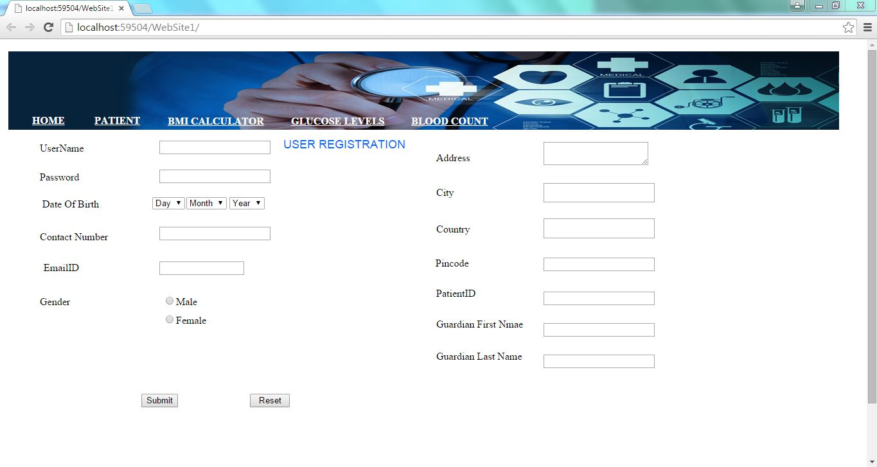

Use case ‘Admin Registration’

Use case attributes
Use Case Description:

This use case deals with the capture of admin details. The ‘admin’ here shall be the operator of the system and will be keying in the admin information into the system.

Scope:

- Admin registration

Actors:

- Admin – the operator

Trigger:

Click ‘Submit’ button in the ‘Admin Registration’ page.

Pre-Condition:

User being able to access the login page & get redirected to the ‘Admin Registration’ page upon click on ‘Register as admin ’ link.

Post Condition:

Admin is in the registration page & submit details.

Flow of Events:

Admin at login page → Click ‘Register as admin’ link → Admin is in the registration page → Admin details are submitted and added onto the database.

Primary Scenario:
A new admin – is able to click ‘Register as admin’ link and able to provide his details and get enrolled in the system.

Business Rules

Business rules should be defined using the following attributes: -

- When the admin clicks on the registration link, it should re-direct to registration form.
    - Admin needs to fill some of the basic attributes/fields as mentioned below in requirement: First Name, Last Name, Age, Gender, Contact Number, User Id, Password
- Clicking ‘Register’ should validate the datatype constraints for each field
- Post-successful field level validation, save the information in the database
- Upon saving the information in the database, display the message ‘Your details are submitted successfully’.

UI Requirements

Here is a prototype on how the ‘login’ page should look like.

Here is a prototype on how the ‘Admin Registration’ page should look like.

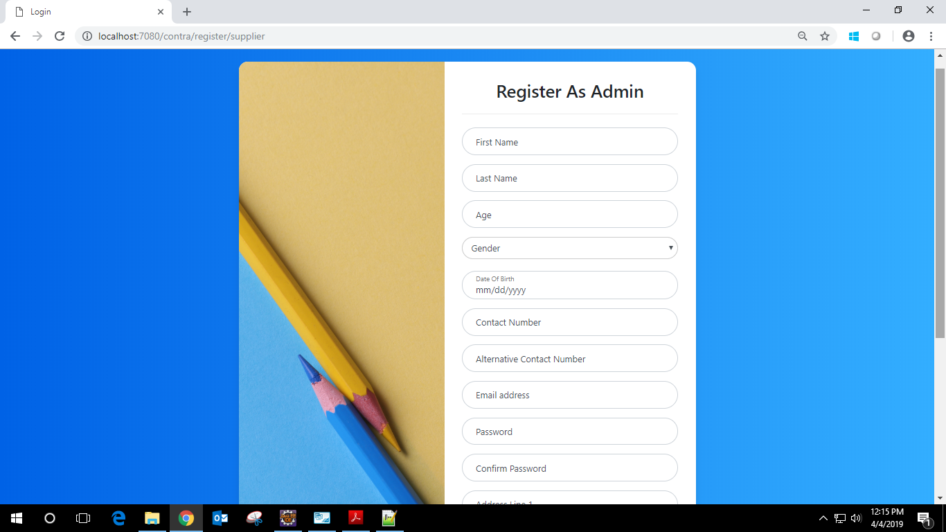

UI Field Validations
Please refer to the below requirements for field level validations:

- All fields are mandatory.
- Username should be less than 30 chars. Password should have minimum 8 chars, no space & can contain special characters (ex.!,@,#,%,*,& etc.)
- Password and Confirm Password fields should be the same
- The Email ID format must be checked. (For ex. test@testmail.com.)
- Phone Number must be of 10 digits’ length

Use case ‘Admin Credential Authentication’

Use case attributes
Use Case Description:

This use case deals with the authentication of the admin credentials. The ‘admin’ here shall be the operator of the system and will be accepting or rejecting the contract and the new suppliers.

Scope:

- Admin credentials authentication

Actors:

Admin – the operator

Trigger:

Click ‘Sign In’ link, after keying in ‘Username’ & ‘Password’ field.

Pre-Condition:

Admin being able to access the admin dashboard.

Post Condition:

Admin is in the Contract checking page.

Flow of Events:

Admin at login page → Key in ’username’ & ‘Password’ field → Admin credentials are validated → Admin homepage is displayed.

Primary Scenario:
A registered admin – is able click ‘Sign In’ link, after keying in ‘username’ & ‘Password’ field and get his credentials authenticated with the existing database entry.

Alternative Scenario:
A registered admin – is able click ‘Sign In’ link, after keying in ‘Username’ & ‘Password’ field and unable to get his credentials authenticated. The admin is presented with relevant error messages:

- Invalid User ID – ‘The supplier provided does not exist in our records’
- Incorrect Password – ‘Password provided is incorrect. Please reach out to your system admin.’

Business Rule
Business rules should be defined using the following attributes:-

- A registered user – is able click ‘Sign In’ link, after keying in ‘Username’ & ‘Password’ field and get his credentials authenticated with the existing database entry.

UI Requirements
Here is a prototype on how the admin contract dashboard should look like.

Use case ‘Contract Addition’

Use case attributes
Use Case Description:

This use case deals with the addition of a new contract. The ‘supplier’ here shall be the operator of the system and will be adding the contract’s description, amenities and terms and conditions.

Scope:

Contract addition

Actors:

Supplier – the operator

Trigger:

Click ‘Sign In’ link, after keying in ‘Username’ & ‘Password’ field.

Pre-Condition:

Supplier should be able to get redirected to the ‘Contract Addition’ page upon clicking the ‘Add contract’ link on the supplier home page.

Post Condition:

Supplier is in the contract addition page and values are submitted in the database.

Flow of Events:

Supplier at login page → Key in ’username’ & ‘Password’ field → Supplier credentials are validated → Click on add contracts link → Enter Contract description → Click next → Enter terms and conditions → Enter amenities → Click finish.

Primary Scenario:
A registered supplier – is able click ‘Add Contracts’ link, and provide contract description, amenities and terms and conditions.

Business Rule
Business rules should be defined using the following attributes:-

- Supplier need to fill the mandatory fields i.e. contract description, amenity1, term1 and condition1.
- Click submit should enter the details into the database.

UI Requirements
Here is a prototype on how the contract addition should look like.

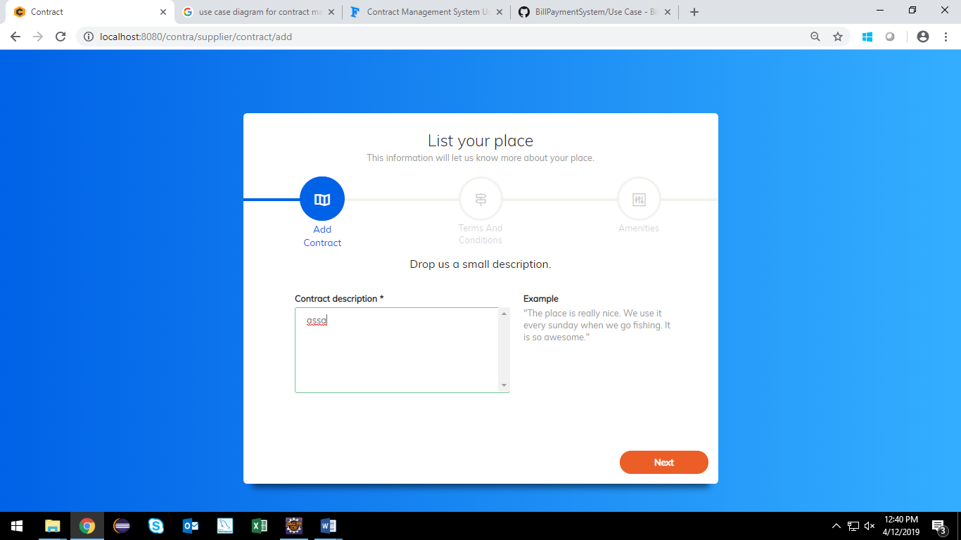

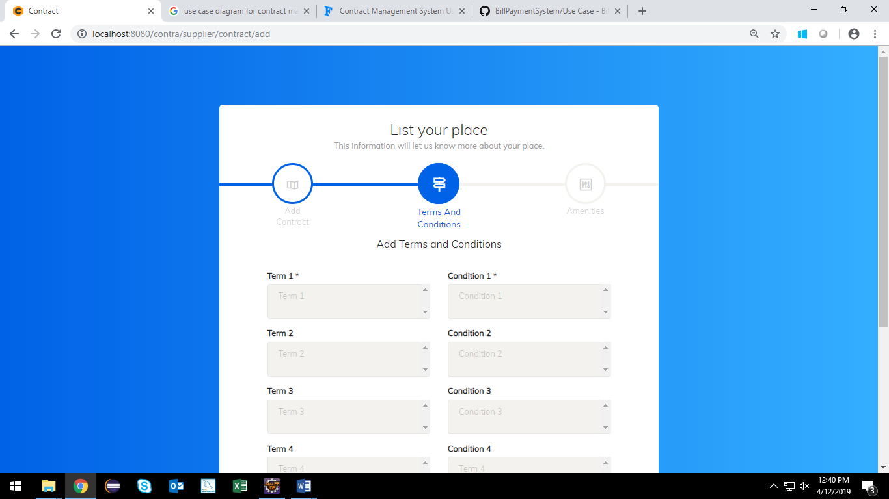

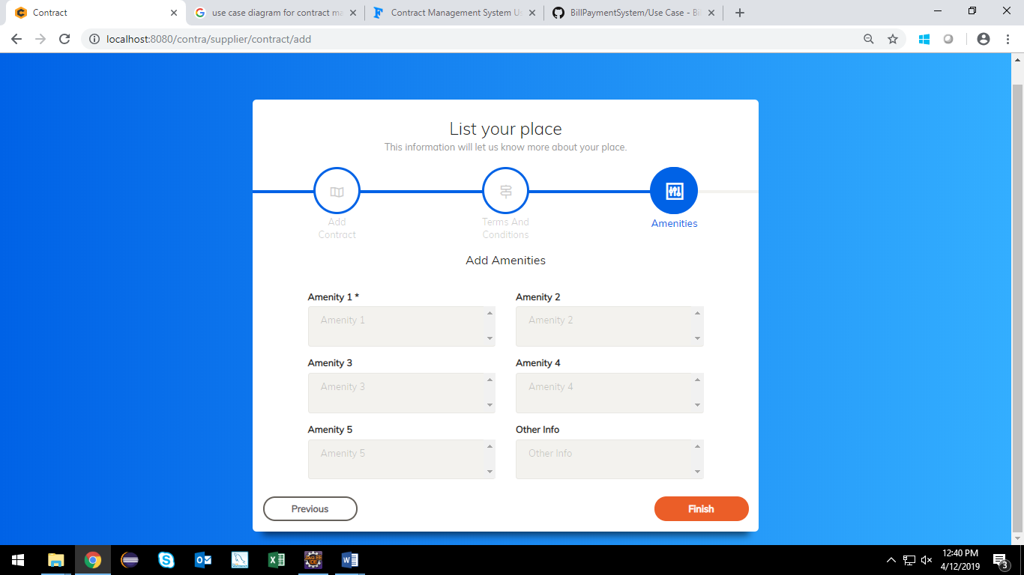

Use case ‘Pending Contracts’

Use case attributes
Use Case Description:

The admin should be able to see all the contracts and accept or reject the contracts.

Scope:

Contract approval or rejection

Actors:

Admin – the operator

Trigger:

Click ‘pending contracts’ link in the admin homepage.

Pre-Condition:

Admin should be able to get redirected to the ‘pending contracts’ table upon clicking the ‘pending contracts’ link on the admin home page.

Post Condition:

Supplier is in the pending contracts page and its status is stored in the database.

Flow of Events:

Admin at login page → Key in ’username’ & ‘Password’ field → Admin credentials are validated → Click on pending contracts link → Accept/Reject the contract .

Primary Scenario:
A registered admin – is able click ‘pending contracts’ link.

Business Rule
Business rules should be defined using the following attributes:-

- Contract status should be displayed in the table.

UI Requirements
Here is a prototype on how the pending contracts should look like.

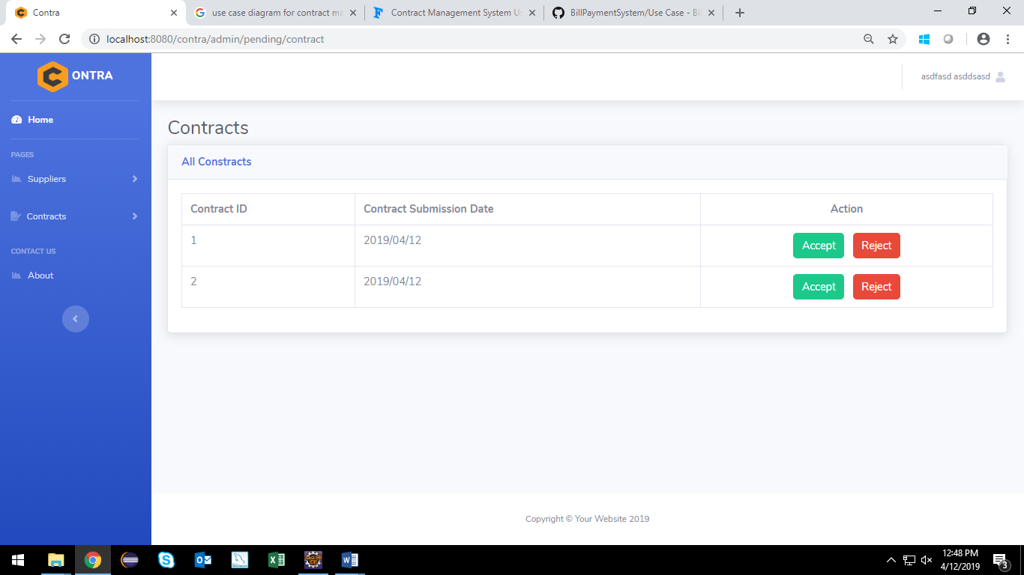

Use case ‘Pending Suppliers’

Use case attributes
Use Case Description:

The admin should be able to see all the newly registered supplier and accept or reject the supplier.

Scope:

Supplier approval or rejection

Actors:

Admin – the operator

Trigger:

Click ‘pending suppliers’ link in the admin homepage.

Pre-Condition:

Admin should be able to get redirected to the ‘pending suppliers’ table upon clicking the ‘pending suppliers’ link on the admin home page.

Post Condition:

Supplier is in the pending suppliers page and its status is stored in the database.

Flow of Events:

Admin at login page → Key in ’username’ & ‘Password’ field → Admin credentials are validated → Click on pending suppliers link → Accept/Reject the supplier .

Primary Scenario:
A registered admin – is able click ‘pending suppliers’ link.

Business Rule
Business rules should be defined using the following attributes:-

- Contract status should be displayed in the table.

UI Requirements

Here is a prototype on how the contract suppliers should look like.
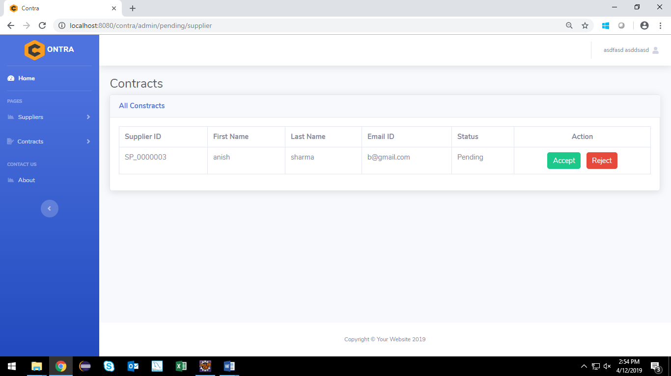

Use case ‘Update profile’

Use case attributes
Use Case Description:

The admin/supplier should be able to change his/her registered data.

Scope:

Profile update by admin/supplier.

Actors:

Admin and supplier.

Trigger:

Click ‘profile’ link on the upper right corner.

Pre-Condition:

Admin/Supplier should be able to get redirected to the ‘profile’ page upon clicking the ‘profile’ link on the upper right corner.

Post Condition:

Supplier/Admin can now change his/her registered details.

Flow of Events:

Admin/Supplier at login page → Key in ’username’ & ‘Password’ field → Admin/Supplier credentials are validated → Click on profile button → Profile update page.

Primary Scenario:
A registered admin/supplier – is able click ‘profile’ link.

Business Rule
Business rules should be defined using the following attributes:-

- Updated information should be reflected in the table.

UI Requirements
Here is a prototype on how the update profile page looks like.

Database Design

Tables Structure
Supplier:
Field Name | Field Type | Datatype | Mandatory | Possible values
Supplier ID | Text(10) | Alphabetic | Yes | System Generated
Password | Text(50) | Alphanumeric | Yes
First Name | Text(50) | Alphabetic | Yes
Last Name | Text(50) | Alphabetic | Yes
Age | Numeric(2) | Numeric | Yes
Gender | Drop Down | NA | Yes | Male, Female
Contact Number | Text(10) | Numeric | Yes
Alternate Contact Number | Text (10) | Numeric | No
Email | Text(50) | Alphanumeric | Yes
Address 1 | Text(100) | Alphabetic | Yes
Address 2 | Text(100) | Alphabetic | Yes
Zipcode | nvarchar | Numeric | Yes
City | Text(50) | Alphabetic | Yes
State | Text(50) | Alphabetic | Yes
Date of birth | Text(10) | Alphanumeric | No

Admin:
Field Name | Field Type | Data Type | Mandatory | Possible Values
Admin Id | Text(10) | Alphabetic | Yes | System Generated
First Name | Text(50) | Alphabetic | Yes
Last Name | Text(50) | Alphabetic | Yes
Age | Numeric(2) | Numeric | Yes
Gender | Drop Down | NA | Yes | Male, Female
Contact Number | Text(10) | Numeric | Yes
Alternate Contact Number | Text(10) | Numeric | Yes
DOB | Text(10) | Alphanumeric | No
Email Id | Text(50) | Alphanumeric | Yes

Contract:
Field Name | Field Type | Data Type | Mandatory | Possible Values
Field Name | Field Type | Data Type | Mandatory | Possible Values
Contract ID | Auto-generated(8) | Numeric | Yes | Non-editable system generated
Contract Description | Text(200) | Alphabetic | Yes
Contract Submission Date | Text(10) | Alphanumeric | Yes
Contract Processing Date | Text(10) | Alphanumeric | Yes
Contract status | Text (10) | Alphabetic | Yes | Submitted Approved Denied

Terms and Conditions:
Field Name | Field Type | Data Type | Mandatory | Possible Values
Field Name | Field Type | Data Type | Mandatory | Possible Values
Contract ID | Auto-generated(8) | Numeric | Yes
Term1 | Text(100) | Alphabetic | Yes
Term2 | Text(100) | Alphabetic | No
Term3 | Text(100) | Alphabetic | No
Term4 | Text(100) | Alphabetic | No
Term5 | Text(100) | Alphabetic | No
Condition1 | Text(100) | Alphabetic | Yes
Condition2 | Text(100) | Alphabetic | No
Condition3 | Text(100) | Alphabetic | No
Condition4 | Text(100) | Alphabetic | No
Condition5 | Text(100) | Alphabetic | No
Other Info | Text(200) | Alphabetic | No

Amenities:
Field Name | Field Type | Data Type | Mandatory | Possible Values
Field Name | Field Type | Data Type | Mandatory | Possible Values
Contract ID | Auto-generated(8) | Numeric | Yes
Amenities1 | Text(100) | Alphabetic | Yes
Amenities2 | Text(100) | Alphabetic | No
Amenities3 | Text(100) | Alphabetic | No
Amenities4 | Text(100) | Alphabetic | No
Amenities5 | Text(100) | Alphabetic | No
Other Info | Text(200) | Alphabetic | No

Change Log
Version Number | Changes Made
V1.0 | Initial baseline created on <dd-Mon-yy> by <Name of Author>
V1.1 | <Please refer the configuration control tool / change item status form if the details of changes are maintained separately. If not, the template given below needs to be followed>
V1.1 | Section No. | Changed By | Effective Date | Changes Effected

